Name: _____________________________ Date: _____________________________

LOGO Lesson 3

Do Now
Underneath each set of instructions write a shorter version using the repeat command
clear  home  fd 100  rt 45  fd 100  rt 45  fd 100  rt 45  fd 100  rt 45  fd 100  rt 45  fd 100  rt 45  fd 100  rt 45  fd 100  rt 45 | clear  home  fd 100  lt 72  fd 100  lt 72  fd 100  lt 72  fd 100  lt 72  fd 100  lt 72 | clear  home  fd 50  lt 90  fd 80  lt 90  fd 50  lt 90  fd 80  lt 90

Homework written down? Green pen out?

Extension:
- Which shape does each command make?
- Sketch ands label the length and angles for each shape.

Learning objective:

To be able to use LOGO to draw circles and curves

Activity One – Drawing a circle
Log on to tiny.cc/mathslogo2 and type in the following code
clear
home
repeat 10
fd 20
rt 36
end

What shape does this make? …………………………………………………………………………………..
What happens when we replace repeat 10 with repeat 20? ………………………………......……………... .............................................................................................................................………………….....…….……………..
Predict how many repeats you will need to draw a full circle°? I predict I will need ....…………………………
Now type in this code:
clear
home
repeat 72
fd 5
rt 5
end

What shape does this make? …………………………………………………………………………………..
Both these codes make the same shape but the numbers are different.
What are the main differences between the two codes? ……………………………………………………………………………………..
……………………………………………………………………………………………………………………………………………………………………………………..
……………………………………………………………………………………………………………………………………………………………………………………..
Let’s look at the code more closely. Answer the questions.
repeat 72
What is the number 72 doing? ………………………………………………….
………………………………………………………………………………………………………
fd 5
What is this code between ‘repeat’ and ‘end’ doing? ……………
………………………………………………………………………………………………………
lt 5
end
What is the word ‘end’ here for? …………………………………………………………………….

LOGO Log #1
Write down what you have learned about LOGO so far today.
Today, I have learned …………………………………………………………………………………………………………………………………………………..
…………………………………………………………………………………………………………………………………………………………………………………….
…………………………………………………………………………………………………………………………………………………………………………………….
…………………………………………………………………………………………………………………………………………………………………………………….

Activity Two – Drawing letters with curves
Here is the code for a C.
clear
home
lt 180
repeat 36
fd 5
rt 5
end

You can type in just to check if you like but you should be able to work it out.

Now complete the code for a S below using ‘repeat’.
clear
You can type your completed code into LOGO to see if this works.
home
repeat …………
fd 5
lt 5
…………
repeat …………
fd 5
………… 5
…………

Practice
Try to write you name in LOGO.
You can use block letters, curved letters, capitals or lower case.

Merit Challenges
yellow
green
red
black
blue
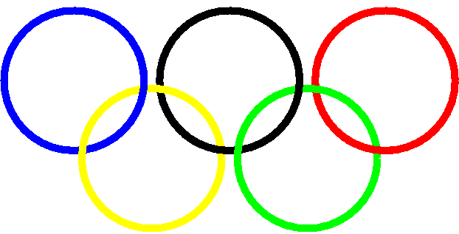
This is the Olympic logo
Your Merit Challenge is to create this logo in LOGO. You must use the five different pen colours on LOGO for the 5 rings.
Remember – This programme is American so the command is pencolor with no u!

Plenary– LOGO exam question
The shape on the right was produced by the code:
clear
home
repeat 5
fd 100
rt 72
end

- Name the shape _____________________________________________________________

- Modify the instructions to make the edges of the shape twice as long.
clear
home

- Modify the instructions to draw 2 of these shapes touching each other edge to edge.
clear
home

