Name: ___________________________________ T A N C Form: ___________________________________
WRITE IN PENCIL / SHOW WORKINGS
Teacher: _________________________________ Date: ___________________________________

Fractions Classic Mistakes* HW
Below each character has made a classic mistake.
I have to shade in $\frac{2}{3}$ of this circle, so I shaded in 2 pieces. Yeah that’ll work!
Under each one write
- What mistake they have made
$\frac{5}{9}$ = $\frac{}{45}$
To find the missing number I multiply 5 by 2. And I get $\frac{10}{45}$.
Is that right?!
- The correct way to do it
$\frac{6}{8}$ - $\frac{1}{8}$ = $\frac{7}{8}$ because the denominators are the same... Am I right?

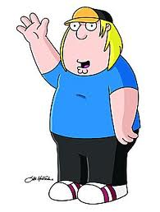
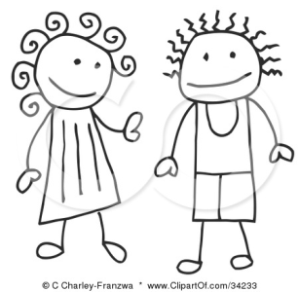
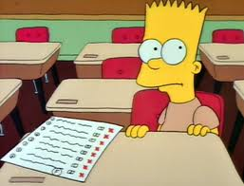

The mistake: ______________________________
____________________________________________
____________________________________________
The correct way:

_____________________________
The mistake: ______________________________
____________________________________________
____________________________________________
The correct way:

_____________________________
The mistake: ______________________________
____________________________________________
____________________________________________
The correct way:

_____________________________

Use the grid to help you calculate the answers to these problems.
I know how to do 7 + 35!
I know 7 + 3 is 10, and then I add on the 5 at the end. So my answer is 105. I’m a genius!

a) 42 × 12
×
4
1
2
2

b) 36 × 21
The mistake: ______________________________
____________________________________________
____________________________________________
The correct way:

_____________________________

How will these classic mistakes help you improve your Xtranormal video?

__________________________________________________________________________________________________________________________________________
____________________________________________________________________________________________________________________________________________
Name: ___________________________________ T A N C Form: ___________________________________
WRITE IN PENCIL / SHOW WORKINGS
Teacher: _________________________________ Date: ___________________________________

Fractions Classic Mistakes HW
Below each character has made a classic mistake.
$\frac{5}{7}$ - $\frac{4}{10}$ = $\frac{50}{70}$ - $\frac{40}{70}$ = $\frac{10}{70}$ because the lowest common denominator is 70. So I did 7 x 10 (which is 70) and for the second fraction I did 10 x 7 (which is 70). Whatever you do to the bottom you do to the top so I did 5 x 10 (which is 50) and 4 x 10 (which is 40). Then I subtract them and I get 10/70!

Under each one write
- What mistake they have made
- The correct way to do it
$\frac{4}{12}$ + $\frac{1}{5}$ = $\frac{5}{60}$ because I find the lowest common denominator for 12 and 5 which is 60, and then I add together 4 and 1.
$\frac{6}{8}$ - $\frac{1}{8}$ = $\frac{7}{8}$ because the denominators are the same... Am I right?

The mistake: ______________________________
____________________________________________
____________________________________________
The correct way:

_____________________________
The mistake: ______________________________
____________________________________________
____________________________________________
The correct way:

_____________________________
The mistake: ______________________________
____________________________________________
____________________________________________
The correct way:

_____________________________

I have to simplify $\frac{198}{220}$ fully. I get $\frac{99}{110}$. Phew! That was easiser than I thought!

2 $\frac{1}{8}-$1$\frac{1}{6}$ = $1$ $\frac{6}{48}- \frac{8}{48}$ = $1$ $\frac{2}{48}$
What I did first was the big 2 take away the big 1 which leaves 1. And I found a common denominator of 48 for the fraction part.
Then I got stuck. I can’t do 6 take away 8! So I swopped them and I did 8 take away 6 and that’s how I got my answer!

I know how to find the volume of this cuboid ! I do 7 x 5 and then I add 12. I’m right aren’t I? I’m a genius!

5cm
7cm
12cm

The mistake: ______________________________
____________________________________________
____________________________________________
The correct way:

_____________________________
The mistake: ______________________________
____________________________________________
____________________________________________
The correct way:

_____________________________
The mistake: ______________________________
____________________________________________
____________________________________________
The correct way:

_____________________________

How will these classic mistakes help you improve your Xtranormal video?

__________________________________________________________________________________________________________________________________________
___________________________________________________________________________________________________________________________________________

