Name: _________________________________ Date: _______________________________

Do Now
Fill in the speech bubbles.
Well Milhouse, you…
Mr Skinner, how do I find the volume of a cuboid?!?

Grandpa, how do I simplify a fraction?

I know! You…

If you have time create your own question and answer using the characters below.

Work Pack
- Turn on your laptop and lower the lid. Now continue reading.

Today you will be composing a short animation involving two characters who are talking about their weekend.

Keep reading...
You will need to go to the website: http://www.xtranormal.com/students

And type in one of the following tokens in the box that comes up:
Find the code for your class!
7 B ZEKB
7 D 96Q5
7 W JRB1

Then when it asks for a username and password, type in your KSA username and password.

When you have done this the top of the home screen will say ‘hi’. See example below.

Click on the ‘Create’ button to start looking through the different collections of cartoon characters.

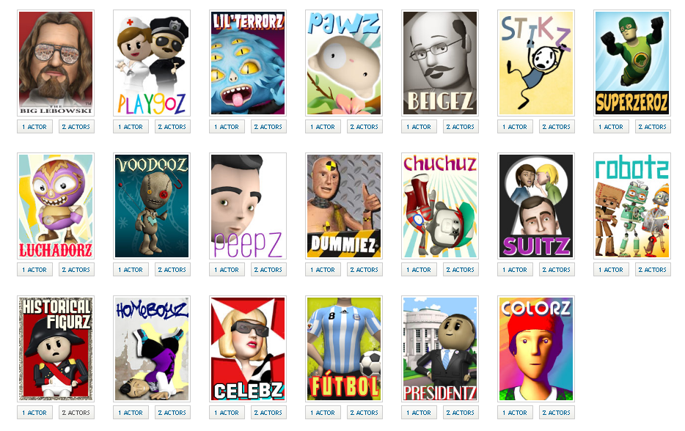
Choosing a collection
Have a look at the different collections you could choose from and decide which one is your favourite.

Put a circle around your favourite collection.

Choosing a Set

Just like when you are reading or performing in a play each scene has a different setting.

Your next task is to pick the set for your movie.

Go to option ‘1. Sets’ and choose a location.

Choosing the characters

Go to option ‘2. Actors’
My favourite two characters are

Skip the ‘3. Sounds’ section.

The Story
Go to section ‘4. Story’.

Use the time to write a script between the 2 characters about what they did at the weekend.
Play around with the different motions, expressions and camera angles your characters can make.

There are various options down the left hand side of the screen.

To choose one, hold the mouse button down and drag it into the script. You will sometimes need to hold the mouse button down for a while so be patient.

Cameras: allows you to see the action from different camera angles.
Choose Auto Camera if you want the computer to choose the best camera angle for you.
Motions: this allows you to get your character to move – there are lots of these so have a look at them all.
Points: this makes your character point in different directions.
Faces: this makes your character show different emotions.
Look-ats: tells your character where to look.
Pauses: makes your character pause in-between what they are saying.
Sounds: add sounds to your movie.

Y7 Topic choices

Below are topics to choose from. There are three levels of difficulty.
Pick your level, and then pick ONE topic that you will teach in your video.

Level 1
- Find an equivalent fraction
- Simplify a fraction
- Add fractions with same denominators
- Explain how to subtract 2 digit numbers like 77 - 24

Level 2
- Convert a mixed number to an improper fraction (or vice versa)
- Add fractions with different denominators
- Find fractions of amounts e.g. 2/3 of £75
- Find the area (and perimeter) of a triangle

Level 3
- Add mixed numbers with different denominators
- How to order fractions
- How to solve worded problems about increase / decrease of price
- When we need to find the highest common factor, and when to find the lowest common multiple

