Do Now
When you get your laptop turn it on and lower the lid whilst it loads.
Read this storyboard, then give your feedback below.
I got a question wrong in NNJR and I don’t know how to do it! Can you help?
How do I find the missing number in $\frac{4}{7}$ = $\frac{}{35}$ ?

Well you need to find a fraction that is the same size as $\frac{4}{7}$ . Fractions that are the same size are called.... errr ... what are they called? Well anyway whatever you do to the bottom you do to the top so you get $\frac{4}{7}$ = $\frac{20}{35}$ . Ta da! Get it?

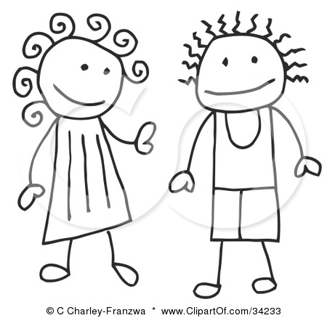
Hmmm... kind of... not sure...

What is good about this storyboard?
____________________________________________________________________________________________
______________________________________________________________________________________________
______________________________________________________________________________________________

What would make it better?
____________________________________________________________________________________________
______________________________________________________________________________________________
______________________________________________________________________________________________
______________________________________________________________________________________________

Spelling Quiz
- ___________________________________  - ___________________________________  - ___________________________________ | - ___________________________________  - ___________________________________  Score: _________________

Xtranormal
- Log onto your laptop if you haven’t already.
- While it loads talk to you partner about how to improve the storyboard you wrote yesterday
________________________________________________________________________
________________________________________________________________________
________________________________________________________________________
Go to the ‘Story’ section of the Xtranormal homepage.
Task
- Type your script into the story section of your video.
- Press the ‘Save’ button from the selection below and remember to save frequently.
- Play your video by pressing the ‘Preview’ button from the selection below.
Listen out for any sections that don’t sound right. Correct these sections using appropriate punctuation within your writing.

- While you wait for your video to load write down what changes you will make to the camera angles and motions.
________________________________________________________________________
________________________________________________________________________
________________________________________________________________________
________________________________________________________________________
________________________________________________________________________

- Change the camera angles and add faces, motions, points and look-ats to improve it.

- Every time you play the video write down the changes or corrections you need to make.
Use the space below to do this.
Camera Angles
Preview your video and write down any changes you want to make to the camera angles.
___________________________________________________________________
___________________________________________________________________
Motions
Preview your video and write down any changes you want to make to the motions.
___________________________________________________________________
___________________________________________________________________

Points
Preview your video and write down any changes you want to make to the points.
___________________________________________________________________
___________________________________________________________________

Faces
Preview your video and write down any changes you want to make to the faces.
___________________________________________________________________
___________________________________________________________________

Look-ats
Preview your video and write down any changes you want to make to who the characters look at.
___________________________________________________________________
___________________________________________________________________
What do you have left to complete? If you have finished do you plan to extend your current video or complete a second one?

