Name: Date: ___________________
Fractions Line Autumn 1 – Week 3 – Extension 2

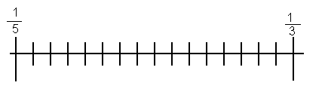
The fractions $\frac{1}{5}$ and $\frac{1}{3}$ have been placed on the number line shown.
Where would $\frac{1}{4}$ go?
Explain your reasoning.
_________________________________________________________________________________________________________________________________________________________________________________________________________________________________________________________________________________________________________________________________________________________________________________________________________________________________________

Design your own fraction puzzle below:

