Name: Date: ___________________
Farey Sequences Autumn 1 – Week 3 – Extension 3

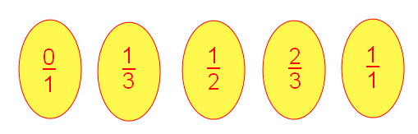
A man called John Farey investigated sequences of fractions in order of size - they are called Farey Sequences.
The third Farey Sequence, F3, looks like this:

It lists in order all the fractions between 0 and 1 , in their simplest forms, with denominators up to and including 3 .
Here is F4:
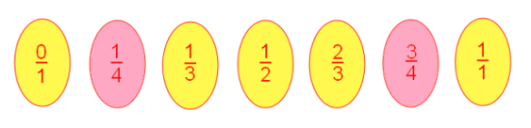
Write down F5 .

Which extra fractions are in F5 which weren't in F4?

Use F5 to help you complete F6 and F7.
F6

F7

Questions:
There are lots of extra fractions in F11 which are not in F10.
There are only a few extra fractions in F12 which are not in F11.
Can you explain why this is the case?
_________________________________________________________________________________________________________________________________________________________________________________________________________________________________________________________________________________________________________________________________________________________________________________________________________________________________________
When will you need lots of extra fractions to get the next Farey Sequence?
_________________________________________________________________________________________________________________________________________________________________________________________________________________________________________________________________________________________________________________________________________________________________________________________________________________________________________
Will every Farey Sequence be longer than the one before? How do you know?
_________________________________________________________________________________________________________________________________________________________________________________________________________________________________________________________________________________________________________________________________________________________________________________________________________________________________________
So far, all the Farey Sequences have contained an odd number of fractions. Can you find a Farey Sequence with an even number of fractions?
_________________________________________________________________________________________________________________________________________________________________________________________________________________________________________________________________________________________________________________________________________________________________________________________________________________________________________

