Name: Date: ___________________
Prime and square number puzzle Autumn 1 – Week 1 – Extension 3

Information:
Two people, Ben and Wasim, are playing a board game with 100 spaces numbered 0 to 99.
 |  |  |  |  |  | 13 | 12 | 11 | 10
0 | 1 | 2 | 3 | 4 | 5 | 6 | 7 | 8 | 9
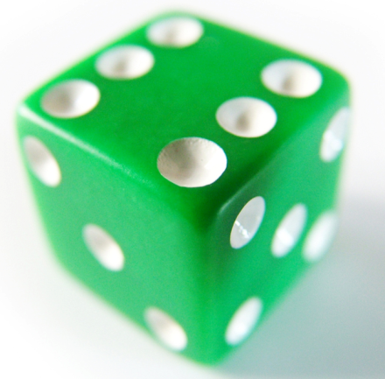
A player starts his counter on 0, rolls a normal die and moves that number of spaces.

Rules:
- If you land on a square number you move forward to the next square number.
- If you land on a prime number you move back to the previous prime number. (If you land on 2 you move back to 0)

When they played the following happened
- Ben rolled first and moved three times as far as Wasim.
- In fact after every go Ben was 3 times as far as Wasim.
- After 5 turns each Ben’s score was 36.

What 5 numbers did Ben roll?

