Name: _______________________________ Form: _______________________________
Teacher: _______________________________ Date: _______________________________

Finding Factors & Classic Mistakes

Do Now
Find all the factors of these numbers:
- 15 _________________________________________________________________
- 19 _________________________________________________________________
- 36 _________________________________________________________________
- 16 _________________________________________________________________
- 62 _________________________________________________________________
Write your homework in the planner.

The Simpsons
Describe the classic mistake that these Simpsons characters have made.

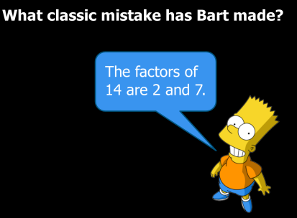 | The classic mistake that Bart made is...  _____________________________________________________________________________________________________________________________________________________________________
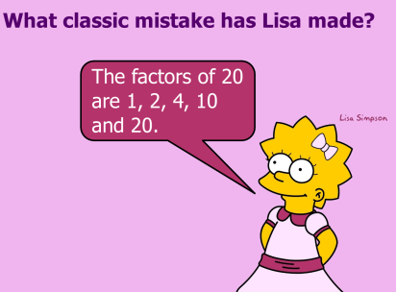 | The classic mistake that Lisa made is...  _____________________________________________________________________________________________________________________________________________________________________
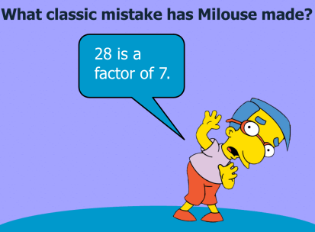 | The classic mistake that Milhouse made is...  _____________________________________________________________________________________________________________________________________________________________________
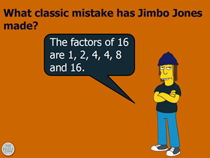 | The classic mistake that Jimbo Jones made is...  _____________________________________________________________________________________________________________________________________________________________________

Find the factors of these numbers but when you do, make some classic mistakes!
Your partner will have to work out which ones are wrong and why!

- 12 _________________________________________________________________
- 9 _________________________________________________________________
- 27 _________________________________________________________________
- 16 _________________________________________________________________
- 22 _________________________________________________________________
- 8 _________________________________________________________________
- 14 _________________________________________________________________
- 48 _________________________________________________________________
- 21 _________________________________________________________________

