Name: ______________________________ T A N C Form: ______________________________
Teacher: Mr Reddy/Ms Povey Date: _________________________
Write in pencil

Infographics HW
Homework help: 07800 888 800 until 8.30pm
Here is an infographic on Harry Potter. Look at it closely to answer the questions below.
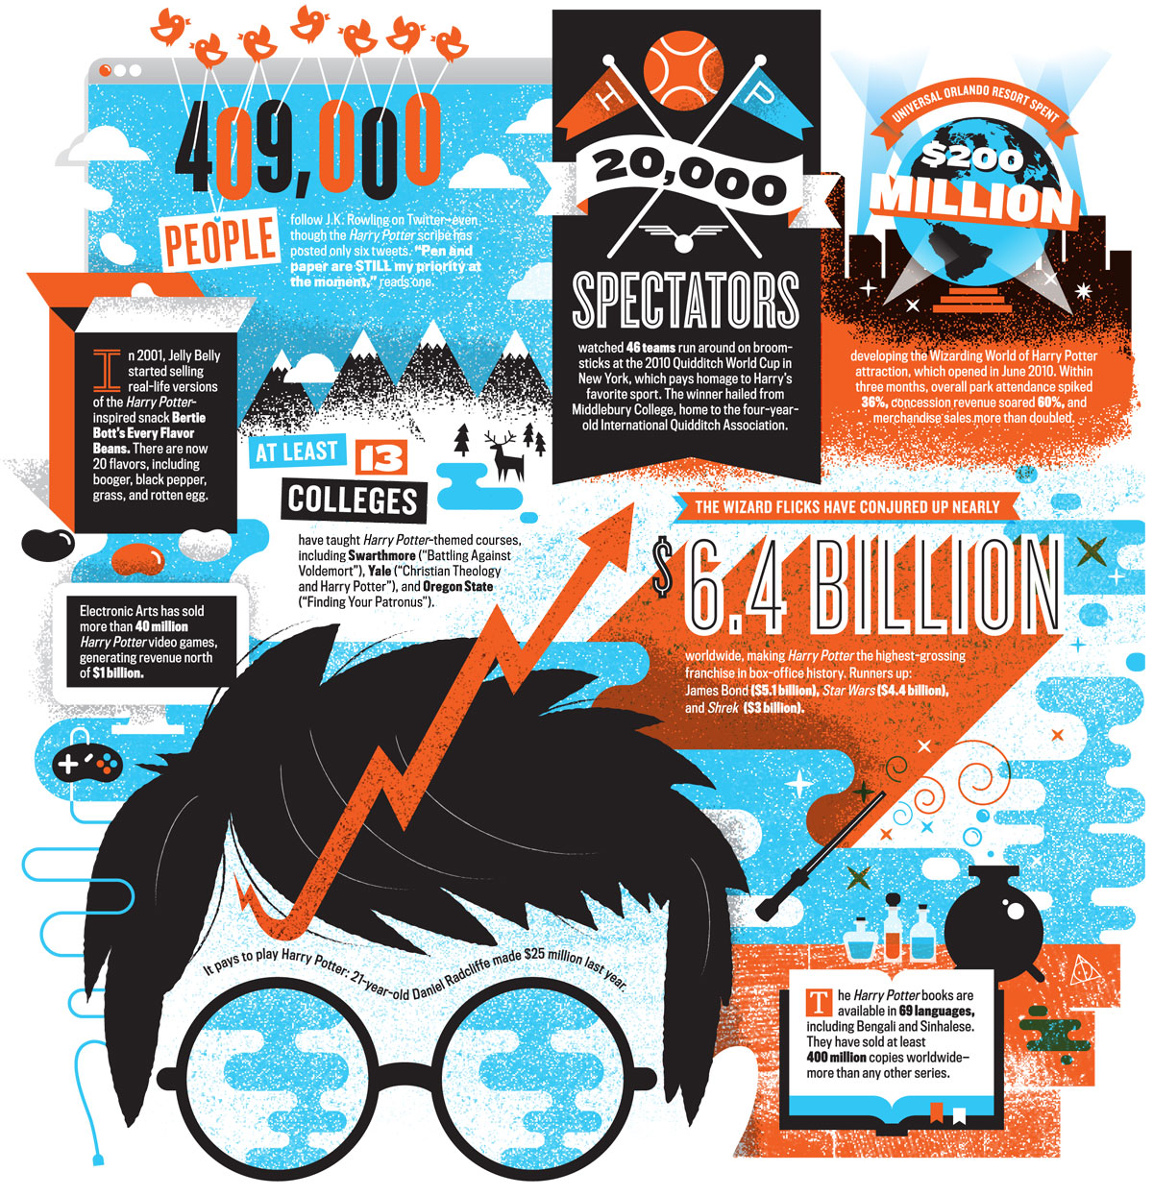
How many people watched the 2010 Quidditch World Cup? ……………………………………
How many Harry Potter video games has Electronic Arts sold? ……………………………………
Name one of the languages in which Harry Potter is available. ……………………………………………………………

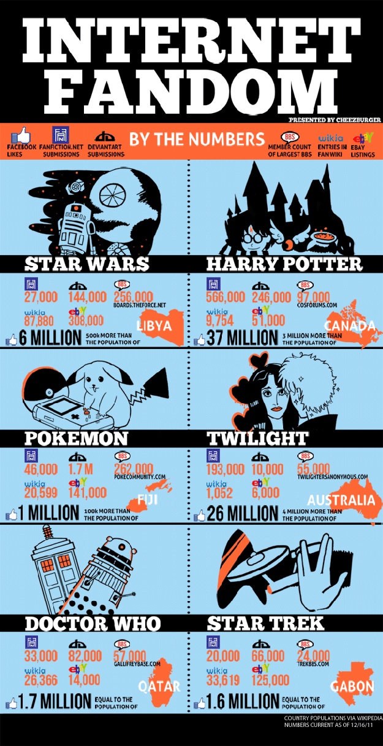
How many Facebook likes did Twilight have?
……………………………………

How many ebay listings does Twilight have?
……………………………………

Which show had the biggest number of FANFACTOR.NET submissions?
Star Wars
Harry Potter
Pokemon
Twilight
Doctor Who
Star Trek
Twilight had 4 million more Facebook likes than which country?
……………………………………

Now you have looked at two infographics. Think about the word ‘INFOGRAPHIC’.
What do you think ‘infographic’ means? ……………………………….……………………………….……………………………….…………………………
……………………………….……………………………….……………………………….……………………………….……………………………….…………………………..

