Name: ______________________________ T A N C Form: ______________________________
Teacher: Mr Reddy/Ms Povey Date: _________________________
Write in pencil

Infographics 2 HW
Homework help: 07800 888 800 until 8.30pm
Here is an infographic on the British Cycling Economy. Look at it closely to answer the questions below.
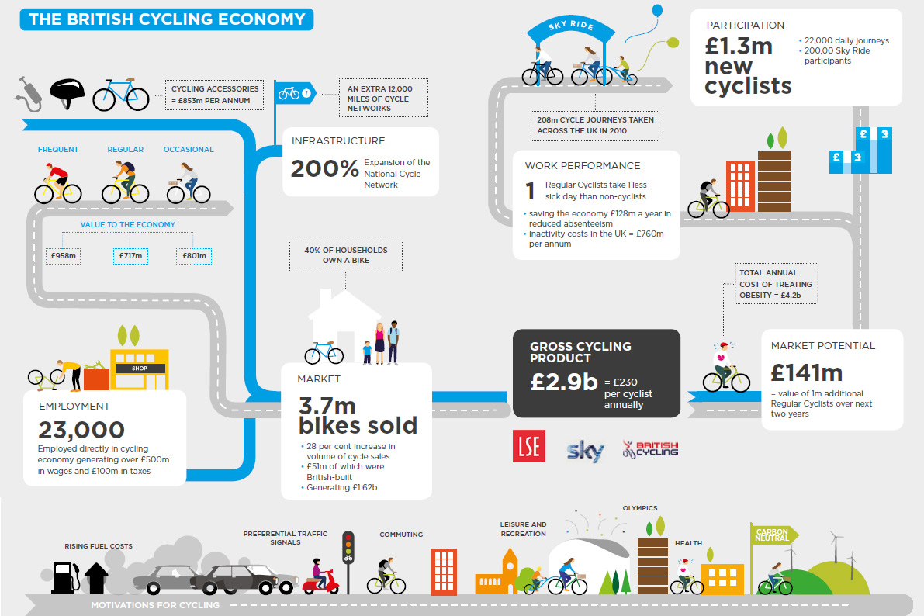

What percentage of households own a bike? ……………………………………

How many people are employed in the cycling economy? ……………………………………

What value to the economy do ‘occasional’ riders represent? ……………………………………………………………

How much money does the economy save from reduced absenteeism? ……………………………………………………………

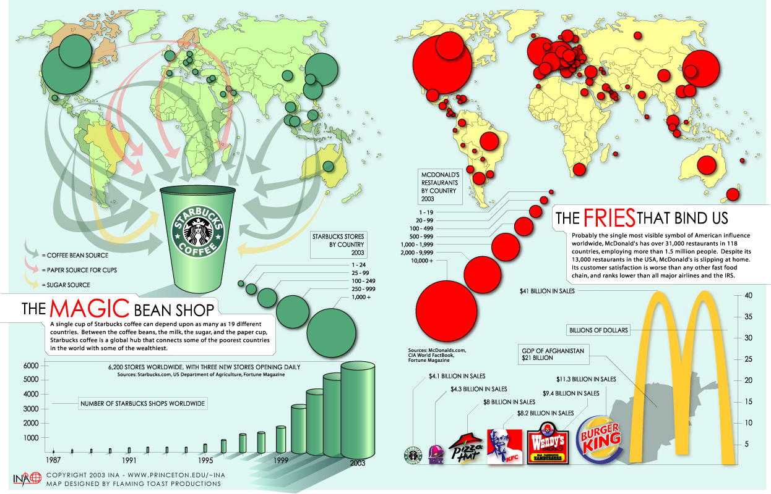
How many Starbucks shops are were there worldwide in 2003? ……………………………………

How many sugar sources are there for Starbucks? (number of countries)
……………………………………
How many people do McDonald’s employ?
……………………………………
Which company had the smallest number of sales?
Starbucks
Taco Bell
Pizza Hut
KFC
Wendy’s
Burger King

Circle the correct answer:
A single cup of Starbucks coffee can depend upon as many as 17 19 22 countries.

McDonald’s has over 31,000 restaurants in 95 118 126 countries.

